Number system - Basics (25th Jan,2018)

https://www.facebook.com/events/814844625377358/

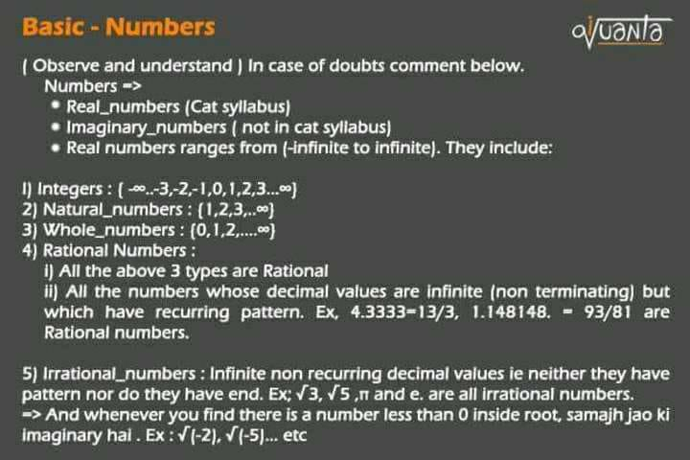

Types of brackets :

(1,2) => means all real numbers between 1 and 2.

[1,2] => means all real numbers including 1 and 2

{1,2} => means only the integers 1 and 2 and no numbers in between.

Hit like when done, comment for doubts

Non terminating are ones which doesn't end after decimal and keeps on going. Now there are two types involved

●Recurring(repeating) and non terminating => Rational

Like those with repeating pattern, 1.333..... , 5.444..., 7.565656....

these are Rational Numbers, as 1.33... can be written as 4/3, ie p/q form

● Non recurring non terminating => Irrational

Those with no such pattern, like 1.3763378..... , 7.46754... , pi, etc

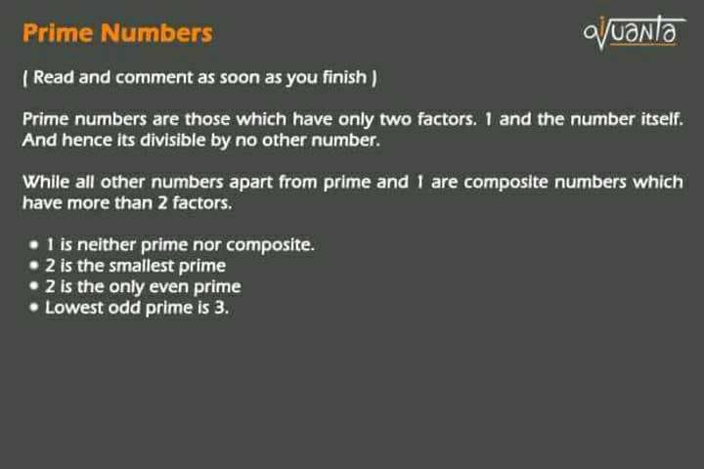

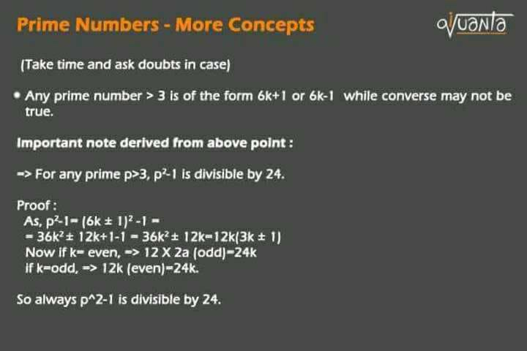

●Proof:   
  
p^2-1= (6k+/-1)^2 -1 = 36k^2+/-12k+1-1 = 36k^2+/-12k=  
  
12k(3k+/-1)  
  
Now if k= even, =>put k= 2a  
  
12\*2a (odd)=24k  
  
if k=odd, the 3k+1 part becomes even   
=> 12k (even)=24k.  
  
So always p^2-1 is divisible by 24.

CAT Past question : Time limit : 30 seconds

If P is any prime > 43

Then what is the remainder when p^2 divided by 24 ?

OA : 1

If p^2 - 1 is completely divisible by 24, p^2 will leave remainder 1.

or p^2 -1=24k hence p^2=24k+1 hence rem=1.

Now one important note :

Note:

LCM , HCF , factors, divisors etc all these are only applicable for Natural Numbers, atleast from CAT perspective. So dont involve negatives in these

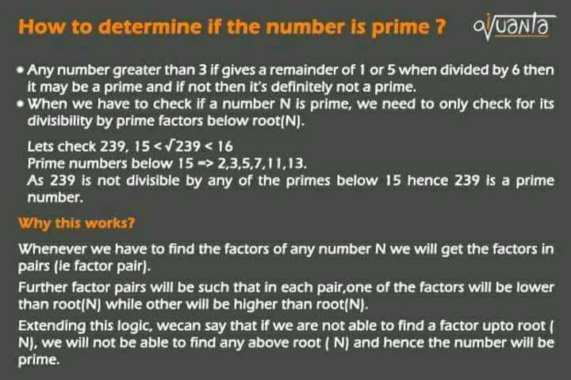

Related to above post

What are factor pairs of 36 ?

1 x 36   
2 x 18  
3 x 12  
4 x 9   
6 x 6

there are 5 factor pairs of 36

its square root is 6,

now lets check for primes below it for divisibility

36 divisible by 2, or 3 , hence not a prime

now we are sure that as its divisible by 2, it must also be divisible by its counter part 18, but we need not check that, checking with 2 was enough.

Now take another ecample of 67, its root = 8.xx

so check for primes below 8, and its not divisible by any of 2 , 3 , 5 or 7 , hence there wont be any other numers above 8 which will be divisible,

Hence 67 is prime.

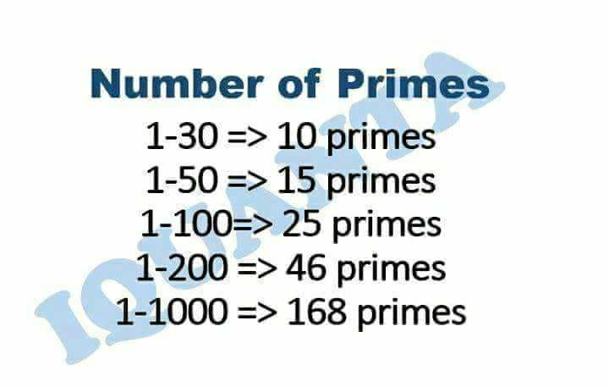

Q.How many primes below 50 are 6k+/-1 form ?

OA : 13 ( because 2 and 3 are not of the form)

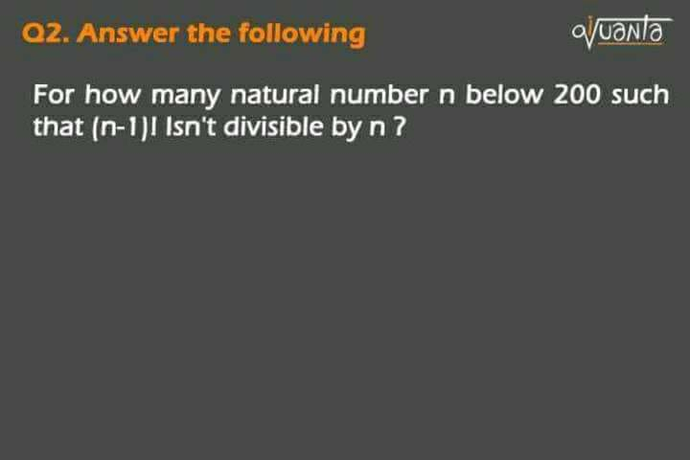

Questuon means: kitne values of n aise honge such that (n-1)! isnt divisible by n.   
  
(n-1)! = 1\*2\*3...\*(n-1) / n   
  
now if n is prime then there wont be any prime below it which can divide n, so 1 to (n-1)! nothing will cancel it so not divisible when n is prime. + one exception case 3!/4 .

OA : 46 + 1 = 47.  
(denominator is the deciding factor).  
(Write down on paper you'll get it).

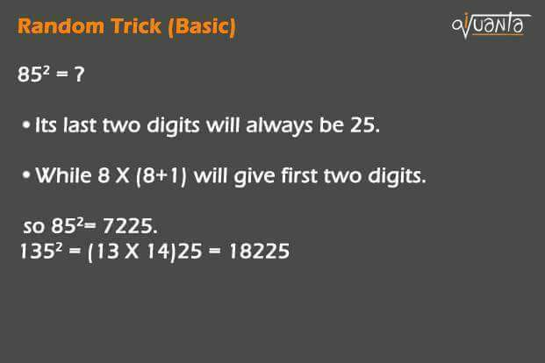

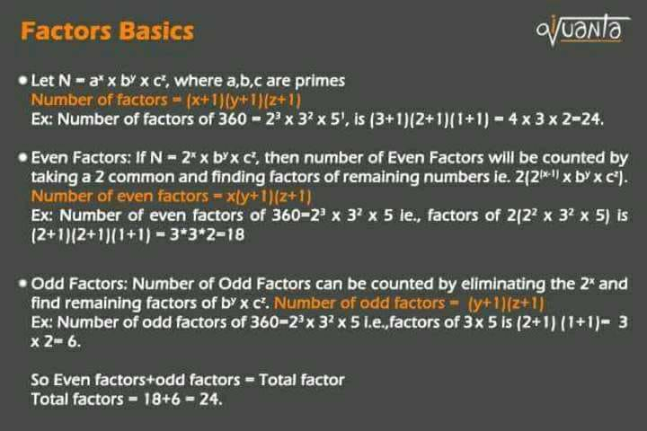

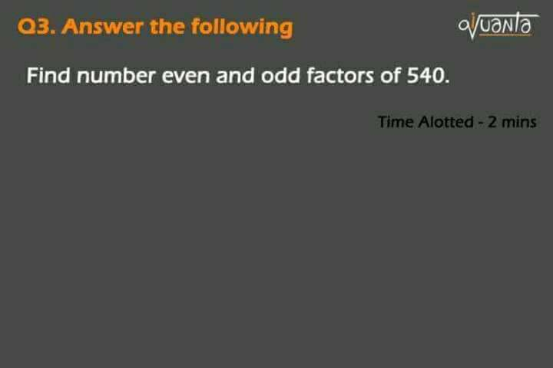

OA : 16,8

Solution: 540=2^2\*3^3\*5  
number of even facotrs = 2(2\*3^3\*5) = 2\*4\*2=16,  
number of odd factors : 3^3\*5 : 4\*2= 8   
total factors: 3\*4\*2=24  
and 16+8=24.

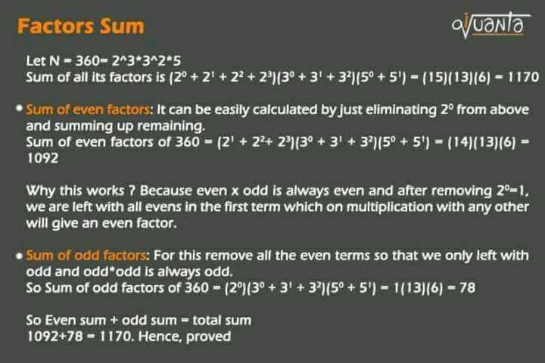

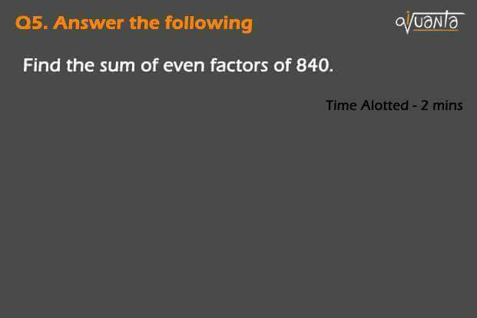

OA : 2688

solution:   
  
840= 2^3\*3\*5\*7  
  
sum of even factors  
  
: (2+2^2+2^3)(1+3)(1+5)(1+7)  
  
=> 14\*4\*6\*8=2688

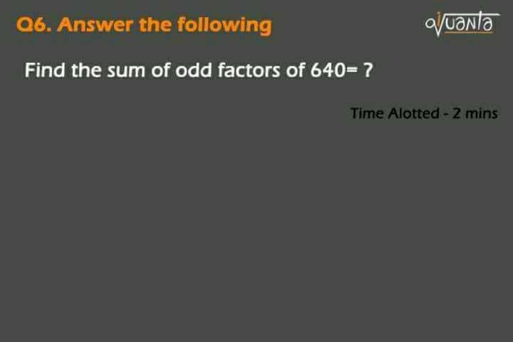

OA : 6

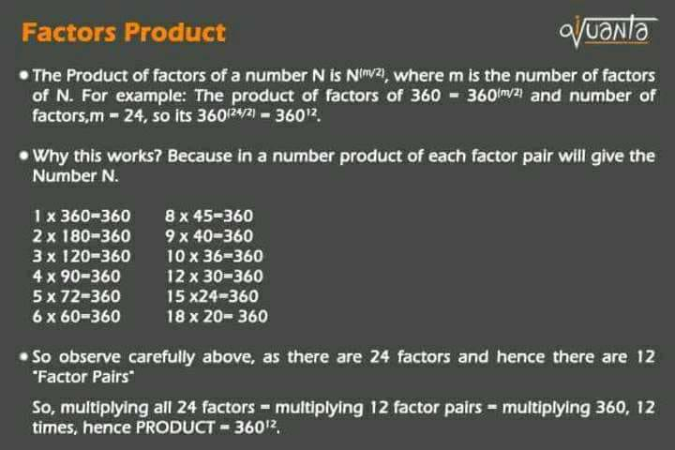

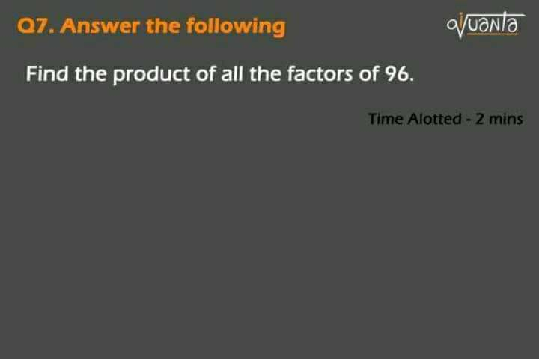

OA : 96^6

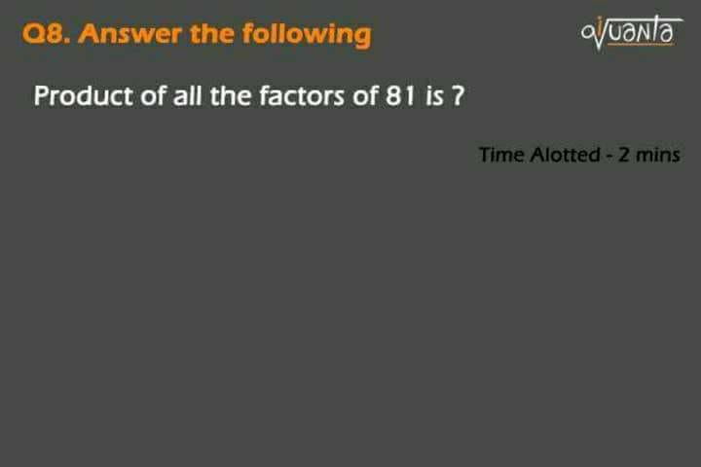

I hope the doubt will be cleared here as we will get odd factors in case the number is a perfect square,   
  
ie., number of the form N^2 so  
  
N^(2\*m/2) = N^(m) ie., still integral form.  
  
Oa : 81^(5/2)= 9^5  
  
So that formula is intact instead of the number being a square( odd number of factors) or not.

Q1: When a certain two-digit Number is added to another two digit number having the same digits in reverse order, the sum is a perfect square. How many such two-digits number are there ?

a) 4   
b) 6  
c) 8  
d) 10

Please Explain it step by step!

Let the number be 10a+b  
  
So, (10a+b)+(10b+a) = 11(a+b)  
  
For it to be square a+b= 11   
  
=> (2,9),(3,8),(4,7),(5,6) and reverse..so 8 cases  
  
So it has 8 solutions

Q2: Consider four-digit numbers for which the first two digits are equal and last two digits are also equal. How many such numbers are perfect squares?

a) 3  
b) 2  
c) 0  
d) 1

Please explain it step by step!

88^2 = 7744